**Protect**

**Barrier Islands**

*Overview:*

Located offshore, barrier islands are dynamic landforms that are formed from offshore bars and, spits. Barrier islands undergo continuous migration through a process of erosion and accretion1, 2 Given the migratory process through which they derive their structure, hard approaches to coastal protection tend to disrupt the formation of barrier islands. Barrier islands have been protected for decades in some areas, e.g., Miami. However, impending SLR could lead to the abandonment of barrier islands as a retreat strategy.2 Barrier islands can be both inhabited or uninhabited. They evolve over time with coastal processes, to form several unique ecosystems, including subaerial beaches, dune fields, interior wetlands, and back-barrier bays or wetlands. These ecosystems provide habitat for a wide range of plants and marine species.

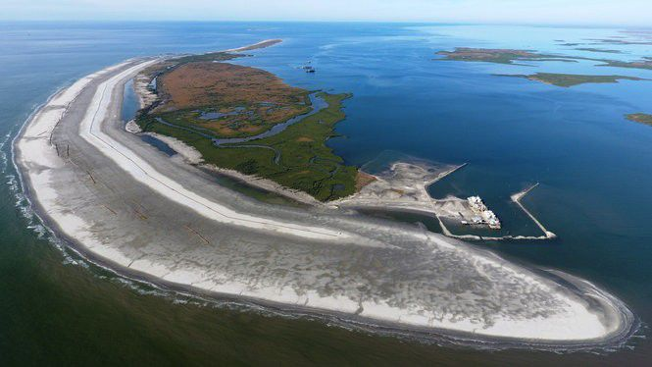

*Figure. 1 Whiskey island Louisiana 4*

***Types of Barrier islands***

* **Bay barriers** enclose a pond, marsh, or other marine ecosystems that are connected by two headlands. They are sometimes referred to as bay mount bar or bay bar.
* **Tombolos** are sand and gravel beaches that connect one or more offshore islands or that connect one or more islands to the mainland. They are sometimes referred to as connecting bars, tie bars, and tying bars.
* **Barrier spits** are barriers that extend into open water and that are attached to a mainland at only one end. Where they extend across a bay or other coastal habitat, barrier spits develop to form bay barriers. Where an inlet is created, a bay barrier can develop into a barrier spit.
* **Dunes or beach barriers** are created when winds that protect landward aquatic habitats form wide sand barrier beaches with hills and ridges. (10)

*Benefits:*

* Provides important support for marine and terrestrial habitats
* Helps to maintain salinity gradients which contribute to supporting a sustainable coastal wetland ecosystem (12)
* Shelters estuaries and protects aquatic ecosystems that exist between the barrier and a mainland.
* Offers storm surge protection through wave attenuation. For example, barrier beaches that front embaymemts absorb wave energy (10)

*Challenges*

* Barriers erode naturally over time due to longshore redistribution of sediments (11)
* Large volumes of sand are required to renourish eroding barriers
* Barriers develop from unconsolidated sediments and are therefore highly unstable and unsuitable for built development
* Erosion of barriers leads to changes in sheltered wetlands including changes in salinity, tidal range, and sediment load. (11)
* Preservation becomes increasingly difficult where there exist high levels of shoreline and bathymetric changes (11)

***Blue Dunes (NJ and NY, USA)***

The Blue Dunes Project is a proposal for a series of offshore barrier islands along the New Jersey and New York harbor.2 The proposal investigates how design can be integrated into the future of coastal protection strategies. The project requires coordination between multiple stakeholders (scientists, engineers, planners, economists, and maritime stakeholders) to address key issues such as water quality, habitat protection, recreation, navigation, construction, and funding.3 Led by the design team *WXY/West 8*, the design of the barrier island considers both the large scale coastal protection and the potential of offshore renewable energy to address the future of coastal life, economy, and property.4

*Mississippi Coastal Improvements Program (MS, USA):*

The Mississippi Coastal Improvements Program is a large-scale barrier island restoration project intended to restore and protect the Gulf Islands National Seashore barrier islands.5 The project began in 2007 with the assistance of the US Army Corps of Engineers (USACE) and other agencies. The project focuses on the re-nourishment of several islands and the restoration of natural sediment transport.6 The dredging and nourishment cost is estimated to be approximately $368 million and requires about 14.5 million cubic meters of sediment.7 Ongoing monitoring by the National Park Service keeps track of the success of the project focusing on sand accretion, restoration of natural transport processes, and protection of cultural resources.8

*References:*

1. “Barrier Island.” *Wikipedia*, Wikimedia Foundation, 2 July 2019, <https://en.wikipedia.org/wiki/Barrier_island>.
2. <https://www.weforum.org/agenda/2018/09/barrier-islands-protect-coastlines-but-they-are-also-vulnerable/>
3. “Blue Dunes– The Future of Coastal Protection.” *Rebuild by Design*, http://www.rebuildbydesign.org/our-work/all-proposals/finalist/blue-dunes--the-future-of-coastal-protection.
4. Ibid.
5. Ibid.
6. Schupp, Courtney A., et al. *Coastal Adaptation Strategies: Case Studies 2015*. pp. 35. https://home.nps.gov/subjects/climatechange/upload/2015-11-25-FINAL-CAS-Case-Studies-LoRes.pdf.https://www.nps.gov/subjects/climatechange/upload/2015-11-25-FINAL-CAS-Case-Studies-LoRes.pdf
7. Ibid, 35.
8. Ibid, 35.
9. Ibid, 35.
10. US Fish and Wildlife Service. (2018). What are Coastal Barrier Landforms? <https://www.fws.gov/cbra/Coastal-Barriers.html>
11. USGS. Science for a changing world. Coastal and Marine Geology program. Louisiana Barrier Islands: A Vanishing Resource, <https://pubs.usgs.gov/fs/barrier-islands/>
12. Knotts, C. P., Grandy, G. M., & Khalil, S. M. (2007). RESTORATION OF LOUISIANA'S BARRIER ISLANDS–EVALUATION AND ANALYSIS. In Coastal Engineering 2006: (In 5 Volumes) (pp. 1977-1988). 1

*Images:*

1. [GEOLOGY AND GEOGRAPHY OF THE NEW YORK BIGHT geo.hunter.cuny.edu](https://www.google.ca/url?sa=i&url=http%3A%2F%2Fwww.geo.hunter.cuny.edu%2Fbight%2Fbeach.html&psig=AOvVaw1ONzqNEySJIbUoxUF34VEW&ust=1592585153011000&source=images&cd=vfe&ved=2ahUKEwjBhuqT6IvqAhUJzawKHbvtAHYQr4kDegUIARCSAQ)
2. WYX/West 8. Blue Dunes Rendering. http://www.rebuildbydesign.org/data/images/724/ap-10-6-13-1-.png.
3. NPS. Barrier Islands Provide Protection for Wildlife, Plants, and Humans. <https://www.nps.gov/guis/learn/nature/images/WildernessLandingPage.jpg?maxwidth=1200&autorotate=false>.
4. Figure 1. Baurick, T. (2020). Building barriers: Inside the race to save Louisiana's first line of storm defense. https://www.nola.com/news/environment/article_df61c669-14cc-5ba7-821d-2ee7c57becd9.html

**Protect**

**Beach Nourishment**

*Overview:*

Beach nourishment (beach renourishment, beach replenishment, or sand replenishment) involves a process of replacing material (usually sand) to a beach that might have been lost by longshore drift or erosion.1 Beach sediment is usually sourced from off-shore dredging and pumped onto the beach area where it is dispersed naturally or mechanically. This increases beach elevation and width. Beach nourishment helps to dissipate wave energy: the wider the beach, the more energy is dissipated.2 Artificial beach nourishment is a long-term maintenance effort. The volume and frequency of fill used will change over time based on the impacts of drivers such as sea-level rise, and other erosive effects along a shoreline. Long-term artificial beach nourishment requires on-going monitoring, funding, and maintenance programs to be successful.2

*Types of beach nourishments:*

* **Backshore nourishment** involves the strengthening of the backshore at the foot of a dune to reinforce the upper portion of a beach. This is done to strengthen the dune against erosion and breaches during an extreme event. Materials are built up at the front of the dune as a buffer. However, this material may be eroded during an extreme event. 11, 12
* **Shoreface nourishment** is generally used in coastal areas where protection measures have resulted in the steepening of the profile of the shoreline leading to long-term sediment deficit. It involves building up the shoreface, i.e., “the area between the mean low water mark and the fair-weather wave base.'' This leads to the reduction of waves which enhances the accumulation of beach material. 11, 12
* **Veneer fill** involves placing beach-quality sands over material that is generally unsuitable for beach nourishment. The unsuitable materials (grossly coarser or finer than normal beach sand), forms the sublayer beneath a thin surface sand veneer. 13
* **Beach and surf zones** are created by depositing sand high up the beach. The sand deposits are protected using revetments, groynes, detached breakwaters, and submerged sills.

*Benefits:*

* Reduces the negative impacts of coastal erosion
* Serves as an adaptive measure against sediment erosion
* Allows for integration with hard solutions, e.g., sea walls
* Provides or restores habitat and supports recreational tourism
* Can help to complement other grey protection strategies, e.g., seawalls or groynes, and green strategies such as dune reinforcement. Beach nourishment can also be improved by contracting dunes that can function as sand reservoirs.
* Is relatively inexpensive and adaptable to changing conditions. Where the beach profile changes the beach can be renourished.
* Materials extracted for other purposes can be utilized for beach nourishment, e.g., material extraction for dredging.

*Challenges*

* Often has unintended (negative) impacts on flora and fauna that occupy the intertidal areas and beaches
* May lead to the introduction of new sediment with different microorganisms
* Requires large volumes of sand (and related challenges with supply)
* Requires ongoing renourishment and financial resources 13

Sand Engine (The Hague, The Netherlands):

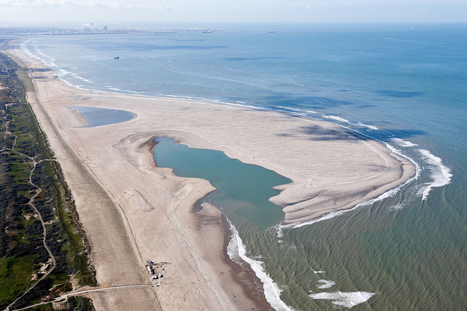

Figure. 1. Sand Engine (The Hague, The Netherlands): 4

The Sand Engine (or Sand Motor) is a unique beach nourishment experiment in using coastal processes (wind, waves, currents) to replenish a section of the Dutch coast over time. This project seeks to prevent flooding by building with nature. During construction, 21.5 million cubic meters of sand dredged 10 kilometers off the coast, was used to create a hook-shaped peninsula.3 Coastal geomorphological processes have since moved significant amounts of the sediment both to the north and south of the Sand Engine.4 This process has created 3,500 acres of new beach and dune. Ongoing monitoring and data collection contribute to tracking geomorphological processes in response to storms and currents. This data will be used to predict behavior, and to determine if sand engines can be used elsewhere. In addition to beach nourishment, the Sand Engine is creating new habitat for flora and fauna, as well as recreational areas for visitors.

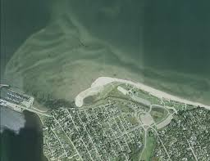

Figure 2. *Parlee Beach Nourishment Program (Pointe-Du-Chene NB, Canada):* 5

The beach nourishment program at Parlee Beach is part of an ongoing management program that uses a portion of the park entrance fee as funding for beach nourishment.5 In addition to mitigating the impacts of storms, the beach nourishment, and associated maintenance and management aims to promote vegetative growth to stabilize dunes. In this way, beach nourishment provides a habitat for marine animals as well as a recreation area for visitors. The volume of sand that is added to the beach varies from year to year. The amount of nourishment required is determined by an annual assessment. The assessment determines the amount of sand lost from storm damage from the previous year.6 As is the case with most beach nourishment programs; the source and match of beach sediment is a challenge. However, with the Parlee Beach Nourishment Program, the material is obtained through land-based processes from sand collected north of the beach.7 Because the harvested sand shares the same characteristics as the local beach sand, it functions similarly and retains the same aesthetics.

***References:***

1. *Beach nourishment, https://www.ctc-n.org/technologies/beach-nourishment*
2. The Arlington Group Planning Architecture Inc., et al. *Sea Level Rise Adaptation Primer*. pp. 77. <https://www2.gov.bc.ca/assets/gov/environment/climate-change/adaptation/resources/slr-primer.pdf>.
3. Sand Engine <http://nlintheusa.com/sand-engine/>
4. Ibid, 77.
5. Parlee Beach Provincial Park Best Management Practices, <https://www.welcomenb.ca/content/dam/gnb/Departments/eco-bce/Promo/Parlee_Beach/pdfs/10_parlee_beach_provincial_park_bmp_July_19_2017-e.pdf>
6. “Introduction.” *The Sand Engine*, https://www.dezandmotor.nl/en/the-sand-motor/introduction/
7. Ibid.
8. The Arlington Group Planning Architecture Inc., et al. *Sea Level Rise Adaptation Primer*. pp. 77 https://www2.gov.bc.ca/assets/gov/environment/climate-change/adaptation/resources/slr-primer.pdf.
9. *Parlee Beach Provincial Park*. pp. 9. https://www2.gnb.ca/content/dam/gnb/Departments/eco-bce/Promo/Parlee_Beach/pdfs/10_parlee_beach_provincial_park_bmp_July_19_2017-e.pdf.
10. Ibid, 9.

11. Climate Adapt. Beach and shoreface nourishment (2015). <https://climate-adapt.eea.europa.eu/metadata/adaptation-options/beach-and-shoreface-nourishment>

12. Citation: Mangor, Karsten (2020): Shore nourishment. Available from http://www.coastalwiki.org/wiki/Shore_nourishment [accessed on 8-10-2020]

1. Finkl C.W., Walker H.J. (2005) Beach Nourishment. In: Schwartz M.L. (eds) Encyclopedia of Coastal Science. Encyclopedia of Earth Science Series. Springer, Dordrecht. <https://doi.org/10.1007/1-4020-3880-1_35>

***Images:***

1. Brobbel, Jurriaan. *The Sand Engine Is a Creative Solution to Beach Erosion*. https://www.hakaimagazine.com/wp-content/uploads/header-sand-motor.jpg.
2. Tourism New Brunswick. *Parlee Beach*. <https://www.nationalobserver.com/Sites/Nationalobserver.com/Files/Styles/nat_header_full_size/Public/Img/2017/05/12/cpt101406131.Jpg?Itok=GcXmft_d>.
3. Dutch engineered sand engine controls floods naturally, <https://www.zdnet.com/article/dutch-engineered-sand-engine-controls-floods-naturally/>
4. Figure 1. Finkl C.W., Walker H.J. (2005) Beach Nourishment. In: Schwartz M.L. (eds) Encyclopedia of Coastal Science. Encyclopedia of Earth Science Series. Springer, Dordrecht. <https://doi.org/10.1007/1-4020-3880-1_35>
5. Figure 2. Parlee Beach Provincial Park

Best Management Practices https://www.bienvenuenb.ca/content/dam/gnb/Departments/eco-bce/Promo/Parlee_Beach/pdfs/10_parlee_beach_provincial_park_bmp_July_19_2017-e.pdf

**Protect**

**Breakwaters**

*Overview:*

Breakwaters are linear, offshore, or onshore structures built to protect the coast from the effects of both storm surges and longshore drift. There are many types of breakwaters including emergent, submergent, offshore, or those connected to the shore. A breakwater can be a single continuous structure or several detached structures.1 A breakwater is usually constructed by stacking large rocks or concrete units in a revetment slope.2 Recently, concrete unit designs have been incorporating ecological functions that enhance habitat sustainability. Such designs have used textured patterns that allow reef systems to thrive.

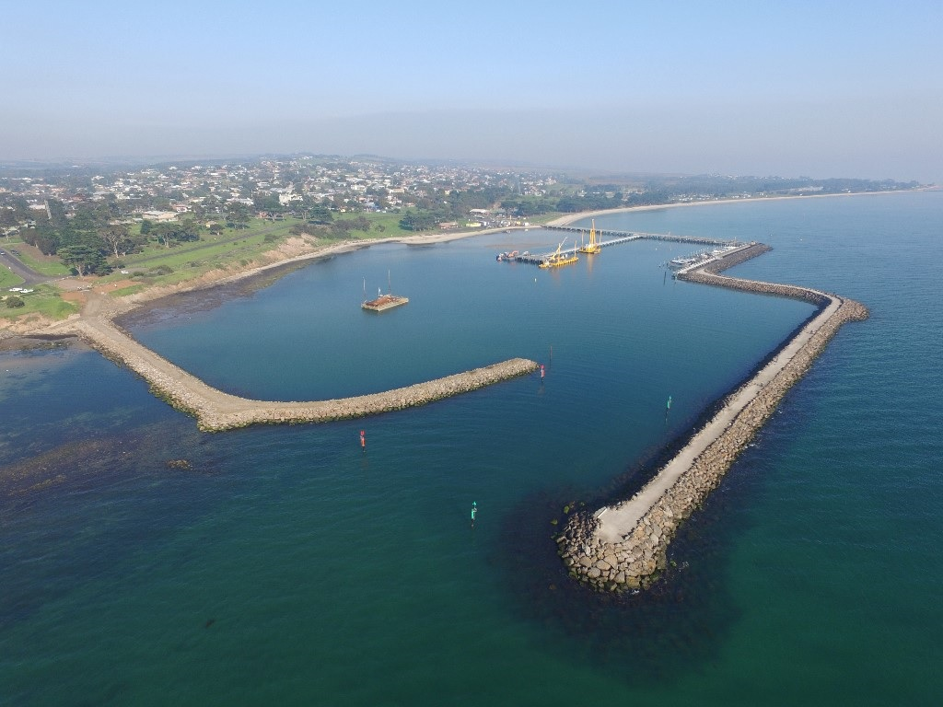

Figure 1. Portarlington harbor breakwater. 4

*Types of breakwater systems:*

* **Detached breakwater** systems are constructed without any direct connection to the shore. These systems are designed to promote sediment deposition on their leeside. They are appropriate in coastlines that are prone to significant sediment transport.
* **Headland breakwater** systems are constructed as a series of breakwater structures that are attached to the shoreline. Each structure is set at an angle. This helps to break up predominant wave patterns. Behind these structures, the shoreline evolves as a log spiral embayment.
* **Nearshore breakwaters** are detached systems that are parallel to the shoreline. They are designed to slow down littoral drift but they produce sediment deposition and shoreline bulge.
* **Rubble mound breakwaters** are constructed using an armor layer, filter layer, and a core. They are built from quarry run rock that is overlaid by large boulders. Wave action is reduced by constructing crown walls at the top of the structure. 14

*Benefits:*

* *Provides storm surge protection from coastal erosion by reducing wave action*
* Protects coastal infrastructure, e.g., harbors and marinas
* Reduces longshore sediment transport behind the breakwater 14
* Create and support biogenic habitats that support marine life. Biogenic habitats are developed from the activities of one or more organisms. Coldwater corals are widely recognized as a biogenic organism.

*Challenges*

* Increases erosion on the lee side (north side) of the breakwater which counters the positive effect of accretion behind the breakwater.
* Offshore breakwaters may hinder onshore sediment transport and thereby prevent the rehabilitation of an eroded beach 14
* Depending on the type of system and design requirements, the cost of construction and maintenance may be high 15
* May lead to habitat fragmentation thereby interrupting the migration of marine species

*Living Breakwaters (Staten Island NY, USA):*

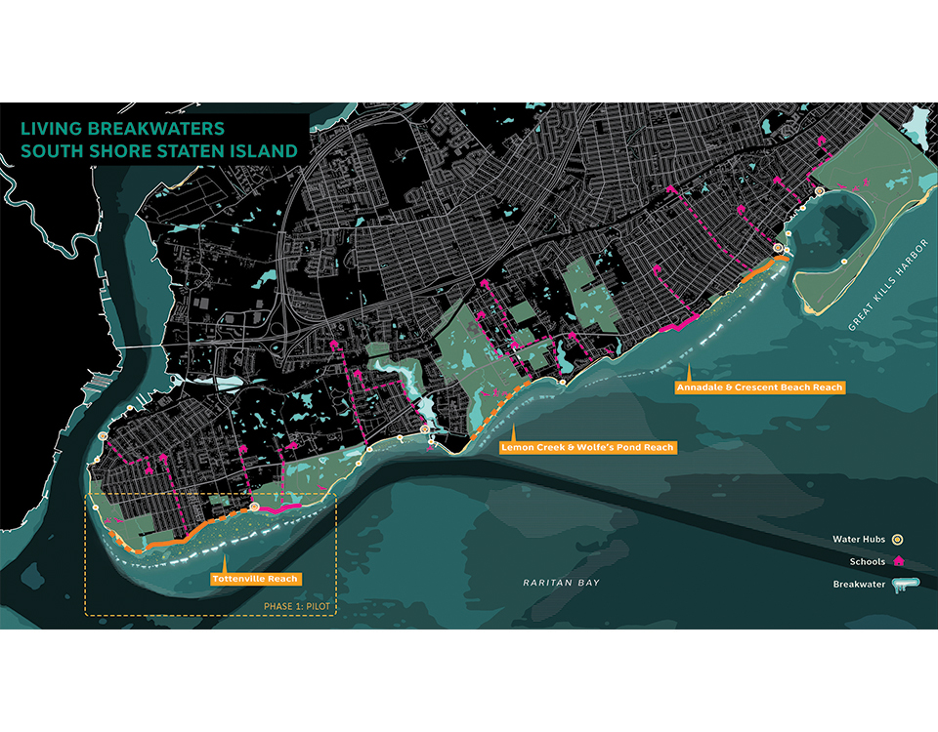

*Figure 3. Living Breakwaters (Staten Island NY, USA): 5*

Living Breakwaters is a Rebuild by Design winning proposal for the design of Staten Island’s south shore. The design concept seeks to reduce risk by building breakwater structures that are ecological resilience. This is achieved using a necklace of offshore breakwaters.3 The design of these unique breakwaters distinguishes them from other breakwater systems. The design also features a mix of sub-tidal beds, forms, and micro-pockets that serve as habitat for different marine species. The breakwaters create a calm environment behind them that promotes water-based activities and land-based activities.4 The project has received $60 million in funding.5

Concrete Oyster Reef Rings (Bengal Islands of Kutubdia, Bangladesh)

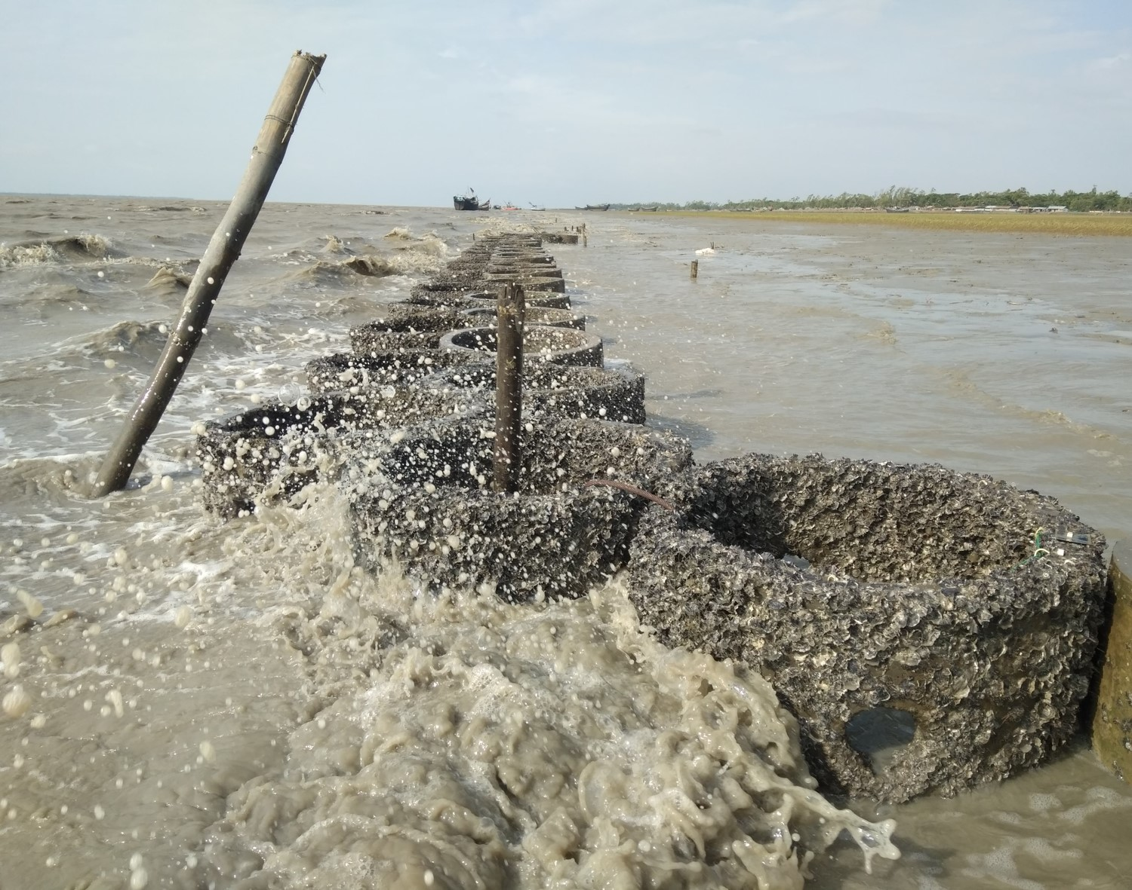

Figure 2. *Concrete Oyster Reef Rings (Bengal Islands of Kutubdia, Bangladesh) 6*

The Bangladesh coast has been severely impacted by both land erosion and accretion and has become an active location for innovative coastal eco-engineering practices.6 Since 1966, soft eco-engineering practices have become increasingly popular as a coastal defense against storm surges and sea-level rise.7 One of the successful examples of soft eco-engineering is the construction of 123 concrete oyster reef rings along the coast of Kutubdia. Each concrete unit has thick perforated walls; 0.8 meters high. The diameter of each unit is 0.5 meters. The cost of each unit is about $50.8 The units are combined to form 3 breakwaters each 20m long that function to reduce coastal erosion, encourage salt marsh development, provide sustainable fisheries and attenuate wave action.9

*References:*

1. *https://www.sciencedirect.com/topics/earth-and-planetary-sciences/breakwater*
2. “Breakwater (Structure).” *Wikipedia*, Wikimedia Foundation, 1 Aug. 2019, https://en.wikipedia.org/wiki/Breakwater_(structure).
3. Ibid.
4. “Living Breakwaters.” *Rebuild by Design*, http://rebuildbydesign.org/our-work/all-proposals/living-breakwaters.
5. Ibid.
6. “Environmental Review Completed for Living Breakwaters.” *Rebuild by Design*, http://www.rebuildbydesign.org/news-and-events/updates/environmental-review-completed-for-living-breakwaters.
7. Chowdhury, Mohammed Shah Nawaz. *Ecological Engineering with Oysters for Coastal Resilience: Habitat Suitability, Bioenergetics, and Ecosystem Services*. pp 15. https://www.wur.nl/upload_mm/6/d/c/7534ff12-d1d1-4088-99de-77a76909ff14_MSNChowdhury_PhD Thesis_2019.pdf.
8. Ibid, 19.
9. Ibid, 21.
10. Ibid, 21.
11. Submerged break water, <https://www.sciencedirect.com/topics/engineering/submerged-breakwater>
12. Firth, L. B., Mieszkowska, N., Thompson, R. C., & Hawkins, S. J. (2013). Climate change and adaptational impacts in coastal systems: the case of sea defences. Environmental Science: Processes & Impacts, 15(9), 1665-1670.
13. Living Breakwater, <http://www.rebuildbydesign.org/our-work/all-proposals/winning-projects/ny-living-breakwaters>
14. Pluijm, M, et al., 1994. Offshore breakwaters versus beach nourishments, a comparison, p. 3208-3222. 24th ICCE, Kobe, Japan
15. Hauer, M., Op den Velde, W., Vrijling, J. K., & d'Angremond, K. (1995). Comparison construction costs conventional rubblemound breakwaters/bermbreakwater.

*Images:*

1. SCAPE. *Rendering of Living Breakwaters*. https://www.scapestudio.com/wp-content/uploads/2018/06/180613_LB.jpg.
2. WUR. *Oysters Have Settled on Concrete Rings Placed on the Coast of the Bengal Island of Kutubdia to Form an Oyster Breakwater Reef That Stops Erosion*. https://www.dutchwatersector.com/sites/default/files/styles/content_m_x2/public/2019-07/wur oyster reefs photo 02.jpg?h=32029293&itok=fd4HueGm.
3. Oyster reefs used to counter large waves https://www.wur.nl/en/Research-Results/Research-Institutes/marine-research/show-marine/Oyster-reefs-used-to-counter-large-waves.htm
4. Figure 1. Maritime. (2017). Completion of breakwaters for Portarlington harbour redevelopment project. <https://www.awmaritime.com/completion-of-breakwaters-for-portarlington-harbour-redevelopment-project/>
5. Figure 2. Rebuild by design. Living breakwater south shore Staten Island. <http://www.rebuildbydesign.org/our-work/all-proposals/winning-projects/ny-living-breakwaters>
6. Figure 3. Wageningen University and Research. (2018). Oyster reefs used to counter large waves. https://www.wur.nl/en/Research-Results/Research-Institutes/marine-research/show-marine/Oyster-reefs-used-to-counter-large-waves.htm

**Protect**

**Coastal Wetlands**

Overview:

Coastal wetlands represent ecosystems that are permanently or seasonally inundated with either fresh, brackish, or saline water that is usually less than 6 feet in depth at low tide. 8, 9 There are different types of coastal wetlands: salt marshes, fresh marshes, mangroves, and sea/eel grasses. In the United States, coastal wetlands cover about 40 million acres and makeup 38 percent of the total wetland acreage.1 The ecosystem services provided by coastal wetlands are essential to people and the environment. Services that are provided can include flood protection, erosion control, habitat and, fisheries preservation, water quality abatement, recreation, and carbon sequestration.2

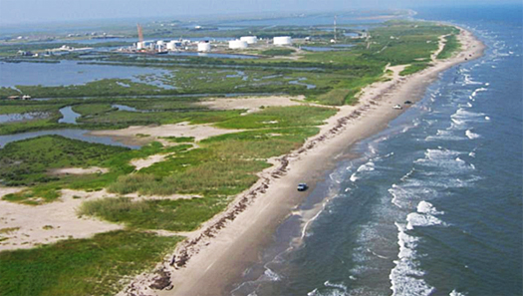

Figure 1. Coastal wetland Louisiana 3

*Types of coastal wetlands:*

* **Tidal salt marshes** are usually found in areas where the accumulation of sediment occurs at the same or higher rate than land subsidence. They are important for supporting the spawning and feeding of several marine organisms. Hence, they represent a critical interface between the land and sea.
* **Mangroves swamps** are estimated to occupy between 16 and 18 million hectares of coastal areas globally. In tropical and subtropical areas, mangrove swamps replace salt marshes. In some instances, both mangrove swamps and salt marshes exist together.
* **Tidal freshwater marshes** are located close to tidal zones, but out of the reach of oceanic salt water. They comprise several features including salt marshes and freshwater marshes. Tidal freshwater marshes possess similar structural and functional characteristics as salt marshes. However, tidal freshwater marshes are more diverse because of reduced salt stress.
* **Riparian wetlands** are ecotones or interfaces that exist between aquatic and upland ecosystems. They possess distinctive vegetative and soil characteristics. Riparian wetlands are difficult to distinguish from surrounding landscapes therefore they are classified as mosaics of landforms and communities within a larger landscape. 10

*Benefits:*

* Protect upland areas from sea level rise, and storm surges by buffering wave action.
* Reduces the frequency and intensity of floods by buffering and storing a significant amount of floodwater.
* Provides habitat for threatened and endangered species.
* Serves as a water filter for chemicals and sediments before they enter coastal waters.
* Sequesters carbon in salt marshes and mangroves. 11

*Challenges*

* Lack of integrated understanding of coastal ecosystems. Wetlands represent complex ecosystem interactions and understanding the interactions between these subsystems is still evolving.
* Transference of knowledge to practice is stymied by conflicts between coastal interests. 12
* Development pressures for residential and commercial space could lead to the loss of wetlands endangered species.
* Habitat degradation from chemicals and sediments due to land-use change inland. 13

***Bluebelt Program (Staten Island NY, USA):***

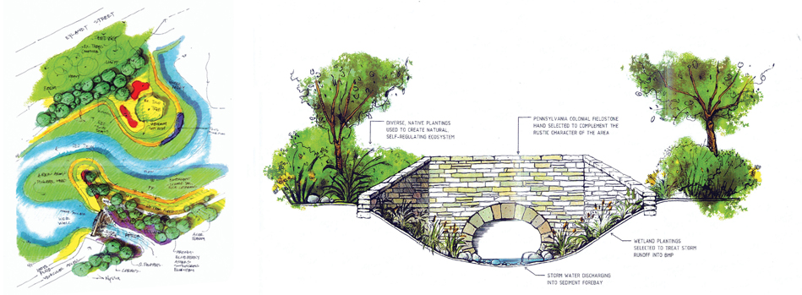

***Figure 2. The Staten Island Bluebelt: Storm Sewers, Wetlands, Waterways 4***

Bluebelt is a cost-effective and ecologically sound drainage system that captures runoff from streets and sidewalks. The program is designed to protect and enhance natural drainage channels, e.g., stream, ponds, and wetland to convey, store or filter runoff from precipitation and stormwater. 8

3 The design and construction of the Bluebelt began in the 1980s when the septic system in Staten Island was failing. During that time, planners recognized the importance of storm management and began acquiring land (wetlands, streams, and ponds) for the Bluebelt program.4 Since the 1980s, several watersheds were reclaimed and the Bluebelt has expanded greatly while improving the drinking water of the City.5

**New Brighton Park Shoreline Restoration (Vancouver BC, Canada):**

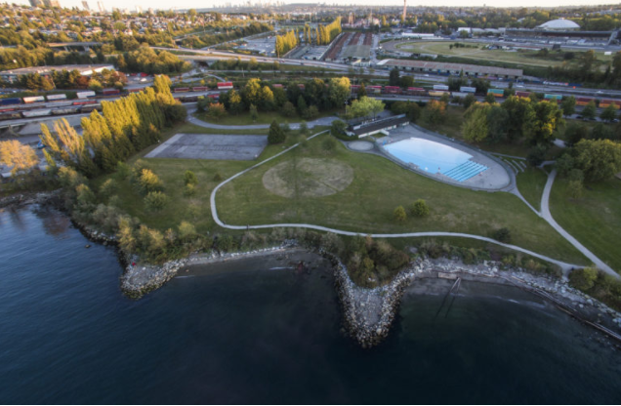 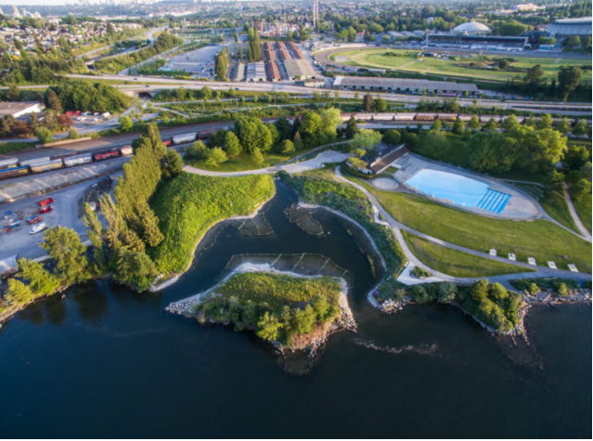

Figure 3. And 4 from left (before) to right (after). New Brighton Park Shoreline Habitat Restoration Project. 5, 6

The New Brighton Park Shoreline Restoration is a collaborative project between the Vancouver Fraser Port Authority, Vancouver Board of Parks and Recreation, and first nation groups to implement a design that supports the Park Board’s Strategic Plan, Rewilding Action Plan, and the Biodiversity Strategy.6 The project features a constructed tidal wetland that provides habitat for juvenile salmon as they migrate along the Burrard Inlet. The wetland also enhances the ecological function of the site by providing a resting and feeding habitat for shorebirds.7 The project is an excellent example of how a small-scale project can be a positive benefit to the overall ecological function of a site.

*References:*

1. “Coastal Wetlands.” *EPA*, Environmental Protection Agency, 1 Mar. 2019, https://www.epa.gov/wetlands/coastal-wetlands#whatAre.
2. Ibid.
3. “The Staten Island Bluebelt Expands Again.” *Freshkills Park*, 11 Sept. 2017, https://freshkillspark.org/blog/staten-island-bluebelt-expands-again.
4. Ibid.
5. Ibid.
6. “New Brighton Park Shoreline Habitat Restoration Project.” *Port of Vancouver*, 4 Oct. 2018, https://www.portvancouver.com/development-and-permits/development/new-brighton-park-shoreline-habitat-restoration-project/.
7. Ibid.
8. In TeGrate. (nd). Coastal processes, hazards and society. <https://www.e-education.psu.edu/earth107/node/1029>
9. <https://www.sciencedirect.com/topics/agricultural-and-biological-sciences/coastal-wetland>,
10. CHAPTER 4 Coastal wetlands: function and role in reducing impact of land-based management G.L. Bruland Natural Resources and Environmental Management Department, University of Hawaii Ma¯noa, USA. <https://www.ctahr.hawaii.edu/brulandg/publications/CWM_Chapter04.pdf>
11. <https://climatechange.ucdavis.edu/climate-change-definitions/coastal-wetlands/>
12. Canadian Science Publishing. 2018. Coastal wetland loss, consequences, and challenges for restoration. <https://cdnsciencepub.com/doi/full/10.1139/anc-2017-0001>
13. NOAA. (nd). Coastal wetlands, too valuable to lose. https://www.fisheries.noaa.gov/national/habitat-conservation/coastal-wetlands-too-valuable-lose

*Images:*

1. NYC Department of Design and Construction. *Bluebelt Wetland*. https://freshkillspark.org/wp-content/uploads/2017/09/DIFk1ZyXkAEKh7Z.jpg.
2. Port of Vancouver. *New Brighton Park Shoreline*. <https://www.portvancouver.com/wp-content/uploads/2018/05/NBP-2018.05.16-0407-1024x767.jpg>.
3. Figure 1. Neherlands News. (2013). Arcadis to design sediment diversion from Mississippi to Louisiana coastal wetlands. <https://www.dutchwatersector.com/news/arcadis-to-design-sediment-diversion-from-mississippi-to-louisiana-coastal-wetlands>
4. Figure 2. Urban Omnibus. (2010). The Staten Island Bluebelt: Storm Sewers, Wetlands, Waterwayshttps://urbanomnibus.net/2010/12/the-staten-island-bluebelt-storm-sewers-wetlands-waterways/
5. Figure 3. Port of Vancouver. (2020). New Brighton Park Shoreline Habitat Restoration Project. <https://www.portvancouver.com/new-brighton-park-shoreline-habitat-restoration-project/>
6. Figure 4. Port of Vancouver. (2020). New Brighton Park Shoreline Habitat Restoration Project. https://www.portvancouver.com/new-brighton-park-shoreline-habitat-restoration-project/

*Video*

(a) Video <https://youtu.be/H5IsENv48-I?list=PLcLNnQfI92DdSOcDZYLKlhXoGpXGlopnf>

**Protect**

**Dikes**

*Overview:*

Dikes are linear compacted earth structures implemented to protect coastal areas from flooding.1 Because dikes are built with a high volume of compacted earth, they are efficient in resisting high water pressure, wave loadings, and overtopping.2 Traditionally, dike construction consists of a sand core, an outer watertight protection layer, toe protection, and a back drainage channel.3 These structures are unique in their typologies and can be designed to enhance the economic, recreational, and ecological value of the coastline. Currently, research is being conducted on how dikes can be more successfully integrated within the landscape and potentially increase the multifunctionality and robustness of dikes while reducing breaches.

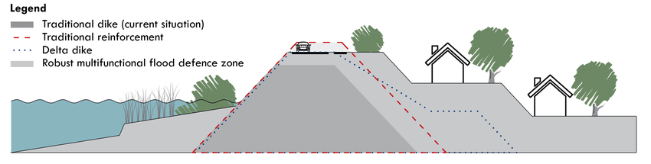

Figure 1. Cross-section profiles of a current dike, a traditional reinforcement, a Delta dike and an unbreachable multifunctional flood defense 2

*Types of dikes:*

* **Superdikes** have a high embankment, a wide base, and a gentle slope. They are usually larger than a standard dike and are designed to withstand earthquakes, erosion, and breaches. Super dikes are designed for water to flow slowly during overtopping. They are also designed to function in low lying urban areas. Hence, they are multifunctional in that they incorporate protection measures for residential, commercial, and recreational spaces. 10
* **A double dike:** the essential feature of a double dike is that the primary dike is not raised thus allowing water to flow over during storm-like weather. A second dike further inland is designed to contain the flow of water over the first dike. 11
* **A triple dike** has a 3-zone defense structure, a front, central and back zone. The central zone acts as a multifunctional dike. The back zone manages water and rainwater runoff while the front zone decreases the impact of waves. 12
* “**The bionic dike** is a concept proposal to reinterpret water safety as 100 percent adaptive.” In this concept the dike has no rigid height, instead, the dike landscape adjusts to environmental changes over time. Developed for the city of In Wageningen the dike is designed to move with the water. When the tide is low the dike opens, when the tide is high the water pressure causes the dike to rise thereby protecting the city. 13

*Benefits:*

* Prevents flooding in low lying coastal areas
* The sloped seaward edge of the dike reduces wave loading and improves wave energy dissipation
* Protects of value development against coastal flooding
* Reduces the effects of coastal erosion by reducing wave energy.
* Reduced toe scour given that the down rush of the wave is directed away from the structure.This reduces the risks associated with undermining.

*Challenges*

* Expensive to construct and requires high maintenance
* Structural integrity decreases over time due to storm damage
* Require large volumes of building materials.
* Requires a large area of land to facilitate the shallow slopes that are needed to aid in wave dissipation.
* Results in fixing the position of the coastline thereby disrupting natural geomorphological processes 14

*Delta Works (The Netherlands):*

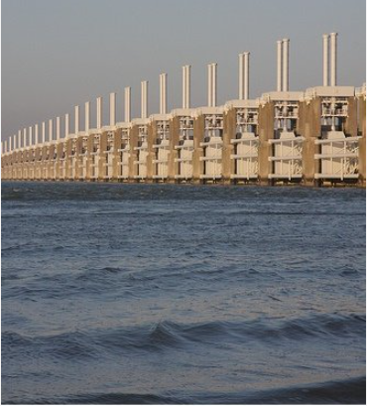

Figure 2. Oosterscheldering, the largest of the 13 delta works dams and barriers 3

Delta Works is a series of flood protection construction projects that were implemented along the Dutch coast in response to the devastating flood of 1953.4 Part of the engineering works was the construction and reinforcement of numerous dikes and levees that have completely changed the Dutch landscape and have become a cultural and historical part of the landscape.5 With the increase in research on climate change and sea-level rise, the Delta committee has initiated long-term plans for the reinforcement of the current flood protection structures. The plan incorporates two approaches: ‘building with nature’ and ‘room for the river’.6 This can be seen in the recent projects: The Sand Engine and The Hondsbossche Dunes, which are intended to reinforce the existing dikes through the concept of working with natural coastal dynamics. Given its scope and significance, Delta Works was designated by the American Society of Civil Engineers as one of the Seven Wonders of the Modern World.

*Richmond Dike System (Richmond BC, Canada):*

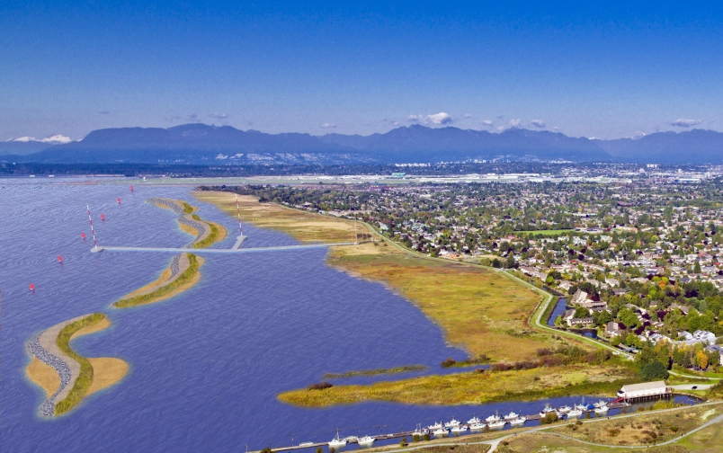

Figure 3. Sketch of artificial sea berms off the foreshore of Sturgeon Bank Richmond B.C. 4

The City of Flood Protection Management Strategy and Dike Master Plans serve as a guiding framework for continual upgrades and improvements to address climate change-induced sea-level rise. The Richmond Dike System was originally constructed in 1860 and surrounds the Lulu and Sea Islands.7 The dike system is an important feature of the settlement of Richmond where it was utilized to protect residential, agricultural, and industrial lands from inundation.8 The dikes have also become a landmark with the integration of recreational trails, vegetation, and structural elements (docks and bridges) known today as the West and South Dyke Trail.9 Although these trails offer beautiful views of British Columbia’s coastal landscape, the structural integrity of the current dike system might be affected by climate change and sea-level rise. In response, the City of Richmond is exploring current plans to upgrade the dike system.

*References:*

1. The Arlington Group Planning Architecture Inc., et al. *Sea Level Rise Adaptation Primer*. pp. 64. https://www2.gov.bc.ca/assets/gov/environment/climate-change/adaptation/resources/slr-primer.pdf
2. Zhu, Xianli, et al. *Technologies for Climate Change Adaptation - Coastal Erosion and Flooding*. 2010, pp. 47. https://orbit.dtu.dk/files/5699563/Technologies for Climate Change Adaptation-Coastal Erosion and Flooding.pdf.
3. Ibid, 47.
4. Kabat, Pavel, et al. *Dutch Coasts in Transition*. Nature Geoscience, July 2009, pp. 450. https://www.researchgate.net/publication/46383972_Dutch_Coasts_in_Transition.
5. Ibid, 451.
6. Ibid, 451.
7. “Dyke System.” *City of Richmond BC - Dyke System*, https://www.richmond.ca/plandev/planning2/heritage/HeritageInv/details.aspx?ID=161.
8. Ibid.
9. Ibid.
10. Floodwise in BC’s Lower Mainland. 2020. Super Dikes. <https://floodwise.ca/reduce-the-risk/infrastructure-works/super-dikes/>
11. De Ingenieur. 2018. DOUBLE DIKE ALONG THE EEMS. <https://www.deingenieur.nl/artikel/double-dike-along-the-eems>
12. Netherlands water partnership. News. 2020. ‘Triple dike’ design aids Shenzhen coastal resilience. <https://www.netherlandswaterpartnership.com/news/triple-dike-design-aids-shenzhen-coastal-resilience>
13. Civic Public Architecture. BIONIC DIKE WAGENINGEN. <https://www.civicarchitects.eu/projects/bionische-dijk-wageningen>
14. Climate Technology Centre and Network. CONNECTING COUNTRIES TO CLIMATE TECHNOLOGY SOLUTIONS https://www.ctc-n.org/technologies/dikes

*Images:*

1. *Dutch Dikes*. <http://dutchdikes.net/wp-content/uploads/2014/12/Hondsbossche-Zeewering-20140601-DSC04137.jpg>.
2. Figure 1. van Loon-Steensma, J. M., & Vellinga, P. (2014). Robust, multifunctional flood defenses in the Dutch rural riverine area. Natural hazards and earth system sciences, 14(5), 1085.https://www.researchgate.net/publication/307711013_Robust_multifunctional_flood_defenses_in_the_Dutch_rural_riverine_area/figures?lo=1&utm_source=google&utm_medium=organic
3. Figure 2. Delta works. <https://www.dutchwatermanagement.com/delta-works-1997-netherlands>
4. Figure 3. Richmond News. Richmond's $300 million dyke plan forges ahead https://www.richmond-news.com/news/richmond-s-300-million-dyke-plan-forges-ahead-1.15299874

**Protect**

**Dune Building / Restoration**

*Overview:*

Dunes develop from sand deposits that represent a store of sediment in the zone just landward of normal high tides. Dune building or restoration is the process of stabilizing existing coastal dunes through coastal management practices such as planting dune vegetation and using sand fences. During storm surges, coastal sand dunes act as a resilient barrier against the disruptive forces of wind and wave action and help reduce the amount of erosion by supplying sand to eroded beaches during storms.1 They also provide habitat for rare and endangered species.2

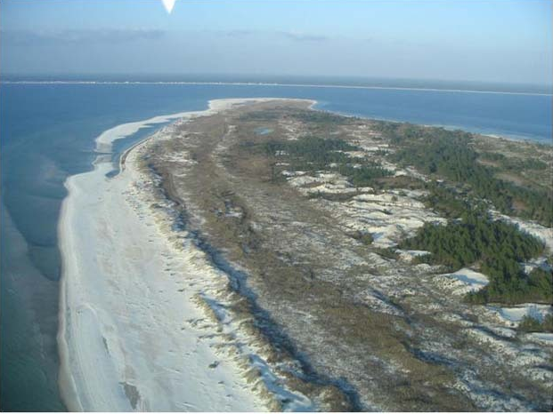

Figure 1. Modern foredune and relict foredunes forming a foredune plain at Cape San Blas, Florida. 3

*Types of dunes:*

* **Blowouts** usually exist within older vegetated dunes in the foredunes. They are landforms of erosional dunes that are usually depressions shaped like a trough, bowl, or saucer. Blowouts may also occur as hollows from wind erosion from an existing sandy substrate or dune.
* **Parabolic dunes** develop from the continuous transport of sand through a blowout. They are composed of two trailing arms that enclose a deflation basin, an actively advancing nose, and depositional lobe. This process leads to the development of a U-shape (i.e., parabolic) or V-shaped dune.
* **Transgressive sand sheets and dune fields** are relatively large aeolian deposits of sand that are formed as a result of downwind movement of sand across a vegetated to semi-vegetated terrain. Transgressive sheets are primarily flat to undulating duneless sheets, whereas transgressive dune fields comprise various types of dunes on the surface
* **Foredunes** develop on the landward side of an active beach at the rear part of the backshore. Generally, foredunes consist of convex, symmetrical to asymmetrical dune ridges parallel to the sore. Although the morphology of foredunes vary they may be placed into three main categories, namely: incipient foredunes, established foredunes, and relict foredunes 7, 8

*Benefits:*

* Provides effective defense against coastal erosion and flooding
* Ability to adjust in response to wind, wave, and sea conditions
* Acts as sand reservoirs that contribute to maintaining beach equilibrium.
* Preserves the structural integrity of beaches to respond to events such as storm surges. 9

*Challenges*

* Requires careful long-term management due to constant change
* Can be overwhelmed by invasive plant species, e.g., grass which can prevent the natural migration of sand
* Invasive plant species on dunes displace native plants that help to stabilize dunes against rapid erosion. This could lead to the encroachment of forest species.

*Hondsbossche Dunes (Noord Holland, The Netherlands):*

In 2015, the Hondsbossche and Pettemer sea dike was reinforced with 30 million cubic meters of sand in a foreshore and beach nourishment. The project was intended to improve flood safety and spatial quality.3 Beach grass and sand fences were used to build an artificial dune landscape. The idea was that the dunes will bolster the protection of the beach from storm surges but also evolve overtime from wind and wave action.

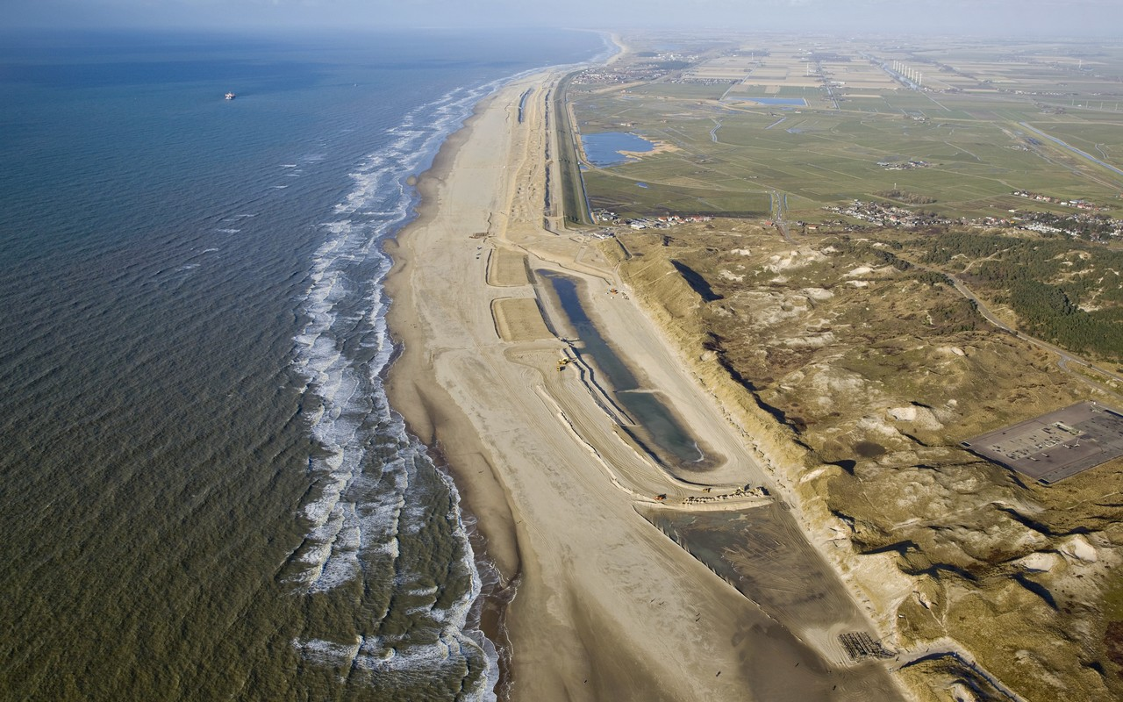

Figure 2. Hondsbossche and Pettemer Sea defence 4

*British Columbia’s Pacific Rim National Park Reserve*

*Figure 3. 5*

Located along the beaches of British Columbia’s Pacific Rim National Park Reserve are some of Canada’s rarest sand dune ecosystems.4 However, the Wickaninish Beach dune ecosystem are being affected by invasive species (European and American Beachgrass), which prevents dynamic sand movement and allows forest land to expand upon the dunes.5 The native plant species have roots that are critical to the structural integrity of the dunes and prevents wave erosion. In 2008, Parks Canada started an ambitious five-year restoration project to restore the Pacific Rim sand dune ecosystem with the primary goal of removing invasive plant species. Monitoring programs show that in 2010 alone over 1 hectare of invasive species was removed and currently over 60% of the dune ecosystem is restored.6

*References:*

1. “Shoreline & Waterway Management.” *Dune Protection and Improvement*, http://www.dnrec.delaware.gov/swc/shoreline/pages/duneprotection.aspx.
2. “Coastal Sand Dunes.” *CRD*, 14 Nov. 2013, https://www.crd.bc.ca/education/our-environment/ecosystems/coastal-marine/coastal-sand-dunes.
3. “Sand Nourishment - Hondsbossche Dunes, NL - Building with Nature Guideline.” *Deltares Public Wiki*, https://publicwiki.deltares.nl/display/BTG/Sand nourishment - Hondsbossche Dunes, NL.
4. Parks Canada Agency, and Government of Canada. “Sand Dune Restoration.” *Sand Dune Restoration - Pacific Rim National Park Reserve*, 28 Mar. 2018, https://www.pc.gc.ca/en/pn-np/bc/pacificrim/nature/restauration-restoration/dunes.
5. Ibid.
6. Ibid.
7. *Sloss, C. R., Shepherd, M. & Hesp, P. (2012) Coastal Dunes: Geomorphology. Nature Education Knowledge 3(10):2https://www.nature.com/scitable/knowledge/library/coastal-dunes-geomorphology-25822000/*
8. *Pacific Rim National Park Dune Restoration (BC, Canada):* [*https://www.youtube.com/watch?v=0UQ7-0QtYMQ*](https://www.youtube.com/watch?v=0UQ7-0QtYMQ)
9. Protection Benefits of Coastal Sand Dunes. http://njseagrant.org/wp-content/uploads/2015/04/draft-DUNE-MANUAL-chapter-3.pdfhttps://www.pc.gc.ca/en/pn-np/bc/pacificrim/nature/restauration-restoration/dunes

*Images:*

1. Damme, Bart Van. *The New Hondsbossche Dunes at Camperduin by Adriaan Geuze/West-8, Petten, NL*. http://www.studiovandamme.com/wp-content/uploads/2015/08/The-New-Hondsbossche-Dunes-at-Petten-by-West-8-Camperduin-NL.jpg.
2. *Restoration Work at Pacific Rim National Park*. <https://www.pc.gc.ca/en/pn-np/bc/pacificrim/nature/~/media/C7243409B0154EB38EF6318A051C9843.ashx?w=500&h=235&as=1>.
3. Figure 1. Sloss, C. R., Shepherd, M. & Hesp, P. (2012) Coastal Dunes: Geomorphology. Nature Education Knowledge 3(10):2. https://www.nature.com/scitable/knowledge/library/coastal-dunes-geomorphology-25822000/
4. Figure 2. Sustainable Earth Actions. (nd). Hondsbossche and Pettemer Sea defence. https://www.vanoord.com/sustainability/climate/hondsbossche-and-pettemer-sea-defence
5. Figure 3. Insert link

**Protect**

**Floodwalls**

*Overview:*

Floodwalls are typically vertical structural barriers that are used in locations where space is limited due to buildings or other land uses.1 The size of floodwalls can vary from 1 ft to over 20 ft in height. They are usually constructed around buildings or other infrastructure that are below flood levels.2 Floodwalls can be more visually appealing compared to other protection structures. Additionally, they can be constructed using a variety of materials and methods to fit with the surrounding landscape and architectural character. Ultimately, the effectiveness of a floodwall is determined by the size of the storms and the technical characteristic of the wall.

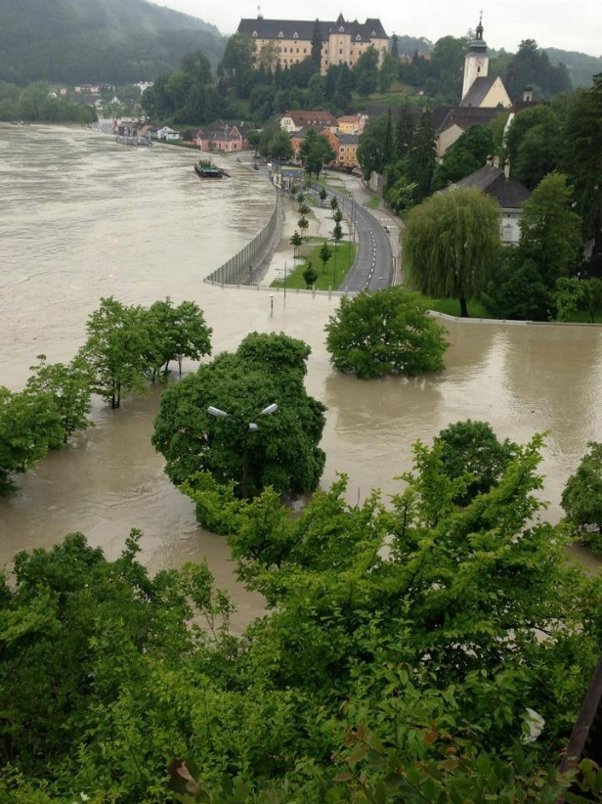

Figure 1 Flood wall in Austrian town 3

***Types of flood walls:***

* **Gravity Floodwalls:** a gravity floodwall derives structural stability from its weight. This is attained by effectively organizing the mass of the wall from the base, to support the weight of the materials at top of the wall. Gravity flood walls are easy to construct however they require a large quantity of materials.
* **Buttress and Counterfort Floodwalls** differ based on the position of their transverse support wall. The transverse support wall is on the heel side of a buttressed wall, opposite to any retained materials. In the case of a counterfort wall, the transverse support wall is on the toe side.
* **Cantilever floodwalls** Constructed mostly using concrete, cantilever floodwalls utilize a cantilever action to restrict any mass behind the wall. It is the most common floodwall because it is economical to design and construct. 10

*Benefits*

* Mitigates against flood damage in areas with high biodiversity and economic and recreational value
* Provides protection from flooding and hence reduces potential physical and economic impacts on infrastructure and livelihoods
* Reduces the need for alternative flood risk management strategies, e.g., community resettlement.
* Complements other flood risk strategies, e.g., wetland restoration
* Possess the capacity to withstand significant flood loads

*Challenges*

* Can lead to unintended consequences on local ecosystems and water flows. For example, flood walls may increase water flow in other areas.
* Might be breached or toppled during an extreme flood event; increasing the damage from floodwaters.
* Overtopping can cause scouring and loss of structural support on the passive side
* During a flood event, a flood side gap may be formed resulting in a fully hydrostatic head along the wall face to the depth of the crack 11, 12

*Kings Lynn Flood Gate*

The Kings Lynn Flood Gate was a response to the flooding of 1978 caused by a North Sea storm surge.3 Sixty flood gates and barriers were constructed. The wall proved to be effective in 2013 during a storm surge, however, upgrades were necessary for future storms.4 As part of the Environment Agency scheme, Flood Control International replaced over sixty gates and installed 30 new gates and barriers that were more effective.5 One of the interesting features of the new flood gates is a seating area that emerges as the gates pivot downward when there is no flooding.

*Britannia Shipyard Floodwall (Richmond BC, Canada):*

As a response to the large flood of 2016, the City of Richmond constructed a 250-meter-long, 2.9-meter-high floodwall for the Britannia Shipyards; a historical site that falls outside the existing dike system.6 The wall is made up of a vinyl sheet pile with wooden cladding and sections that are open to allow walkway access into the site.7 During a storm surge, the sections are closed off by aluminum flood panels to ensure the complete length of the wall is water-tight.8 The floodwall is part of Richmond’s $300 million Dike Master Plan to reinforce the existing Richmond Dike System over 80 years.9

*References:*

1. The Arlington Group Planning Architecture Inc., et al. *Sea Level Rise Adaptation Primer*. pp. 69. https://www2.gov.bc.ca/assets/gov/environment/climate-change/adaptation/resources/slr-primer.pdf
2. FEMA. *Selecting Appropriate Mitigation Measures for Flood prone Structures*. 1 Mar. 2007, pp. 2. https://www.fema.gov/media-library-data/20130726-1608-20490-6445/fema551_ch_05.pdf.
3. “King’s Lynn Flood Gate Replacement and Refurbishment.” *King's Lynn Flood Gate Replacement and Refurbishment - Case Study*, http://www.floodcontrolinternational.com/CASE-STUDIES/case-study-kings-lynn.html.
4. Ibid.
5. Ibid.
6. Wood, Graeme. “Steveston Site Gets a Bigger Flood Wall.” *Richmond News*, 8 Jan. 2018, https://www.richmond-news.com/news/steveston-site-gets-a-bigger-flood-wall-1.23138686.
7. Ibid.
8. Ibid.
9. Wood, Graeme. “Richmond's $300 Million Dyke Plan Forges Ahead.” *Richmond News*, 13 Apr. 2017, <https://www.richmond-news.com/news/richmond-s-300-million-dyke-plan-forges-ahead-1.15299874>.
10. FREIE UNIVERSITÄT BERLIN. Department of Earth Sciences. Floodwalls. INTEGRATED WATER RESOURCE MANAGEMENT - FROM TRADITIONAL KNOWLEDGE TO MODERN TECHNIQUES: https://www.geo.fu-berlin.de/en/v/iwrm/Implementation/technical_measures/Flood-protection-measures/structural_measures/Floodwalls/index.html Benefits:
11. Bureau of Reclamation. (2020). Risk Management. Best Practices and Risk Methodology. <https://www.usbr.gov/ssle/damsafety/risk/methodology.html>
12. US Army Corps of Engineers. (2017). Floodwalls
13. Best Practices in Dam and Levee Safety Risk Analysis. https://www.usbr.gov/ssle/damsafety/risk/BestPractices/Presentations/E8-FloodwallsPP.pdf

*Images:*

1. *Flood Gates That Accommodate Seating*. http://www.floodcontrolinternational.com/CASE-STUDIES/Resources/KL-bench-gate1.jpg.
2. *The City of Richmond Has Built a Bigger Flood Wall for Britannia Shipyards*. <https://images.glaciermedia.ca/polopoly_fs/1.23138688.1515437941!/fileImage/httpImage/image.jpg_gen/derivatives/landscape_804/shipyards-wall.jpg>.
3. Figure 1 English, T. (2016). Mobile Flood Walls Keep This Austrian Town Safe. <https://interestingengineering.com/mobile-flood-walls-keeps-austrian-town-safe>

**Protect**

**Groynes**

*Overview:*

Groynes are rigid structures, typically constructed using heavy materials extending from the upper shore to the water.1 They are used in combination with beach nourishment by trapping beach material that is transported during high wave conditions.2 Groynes can be constructed using various materials including timber, steel, concrete to rubble-mounds. Each material has different strengths and weaknesses and life expectancies. Long-term maintenance is required, and the replacement of groynes are common in flood management plans. As a response to downdrift erosion construction of groynes should be accompanied by a regular recycling or nourishment program.3

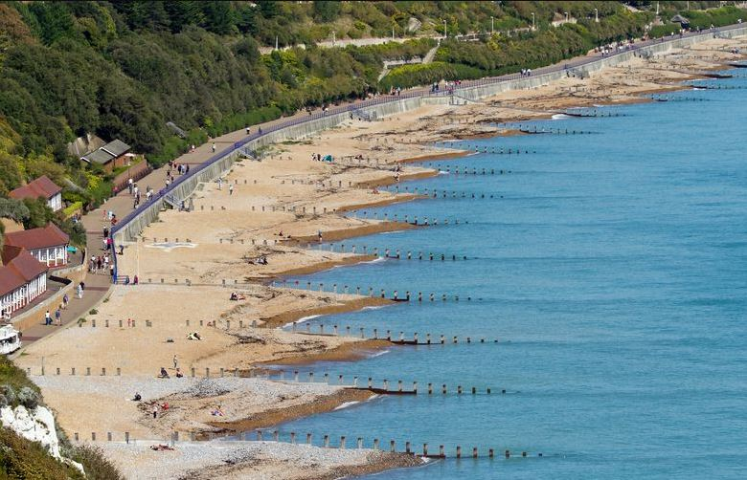

Figure 1 Groyne sea defence 3

*Types of groynes:*

* **Wooden groynes** usually consist of one or two-row palisade structures that are usually permeable. Wood groynes are cheap but have low durability.
* **Rock groynes** are simple to construct and have long durability. They can also be dismantled and reinstalled
* **Concrete groynes** are usually constructed from prefabricated boxes or reinforced concrete hence they are very durable and long-lasting. However, they require a foundation with a high load-bearing capacity
* **Rubble-mound groynes** can be built using loose mounds of stones or other materials, e.g., tetrapods 13

*Benefits*

* Creates an opportunity for beach widening which is valuable to recreational tourism.
* Traps sediments and widens beach thereby reducing erosion and increasing wave energy dissipation.
* Acts as a sturdy structure which can be used for long term stabilization of coastline
* Can be used in tandem with other approaches, e.g., beach nourishment and hard engineering measures
* Enjoys widespread global acceptance based on experience with design and construction.

*Challenges`*

* Provides limited protection against extreme storm events
* Reduces transport of sediments down the coastline
* Causes downdrift erosion
* Complementary to artificial nourishment, e.g., could reduce positive impacts on coastlines down-drift
* Rip currents may occur adjacent to groynes presenting hazards to bathers and other users
* May lead to sediment loss during storm events
* May negatively impact coastline appearance, given its unnatural, shore perpendicular structure 14

*Aberdeen Beach Groynes (Aberdeen SCT, UK):*

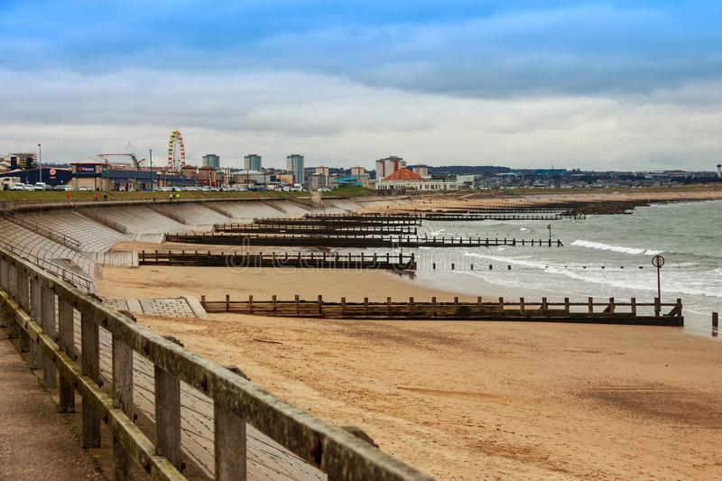

Figure 2. *Aberdeen Beach Groynes* 4

Historically, Aberdeen Beach has had significant problems with coastal erosion and has experienced a substantial loss of beach sediment. This is based on the inspections that were done in 2001 and 2004.4 Beach elevation in front of the seawall has decreased to the point where sheet piling was exposed, causing the seawall to be exposed to failure.5 In response, in 2006, the Aberdeen City Council decided to implement a major beach nourishment and groyne construction program.6 Across a 600m stretch of the Aberdeen Beach, 750 m of dredging pipeline was used to pump 70 000 m3 of dredged sand along the beach and 1800 tons of granite blocks were used in the construction of 5 groynes.7 This represented a reactive response to the coastal erosion along the seawall. However, with climate change and sea-level rise, there are still concerns about the long-term durability and consequences of the groynes.

*Crescent Beach Groynes (Surrey BC, Canada):*

Coastal erosion has been a problem at Crescent Beach since 1914, in response, a timber groyne system was implemented along the West Beach.8 The groyne system helps to protect the beach from further erosion and the existing dike.9 In 1999, an assessment was done to identify the causes of shoreline erosion that was observed years after the construction of the groynes.10 The study showed that the cause of shoreline erosion was due to the decrease in sediment supply, sediment transport, damaged groynes, and frequent storm events.11 Since 2001, remediation of the beach was undertaken including the repair and replacement of the groynes and a recommendation for beach nourishment.12

*References:*

1. The Arlington Group Planning Architecture Inc., et al. *Sea Level Rise Adaptation Primer*. pp. 68. https://www2.gov.bc.ca/assets/gov/environment/climate-change/adaptation/resources/slr-primer.pdf
2. “Groynes.” *Groynes | Coastal Management Webguide - RISC KIT*, https://www.coastal-management.eu/measure/groynes-0.
3. Ibid.
4. *Aberdeen Beach Case Study*. University of Aberdeen, pp.8. https://www.abdn.ac.uk/geosciences/documents/Aberdeen_Beach_-_Case_Study.pdf.
5. Ibid, 8.
6. Ibid, 8.
7. Ibid, 8.
8. *Crescent Beach Erosion Protection*. pp. 2. https://www.surrey.ca/bylawsandcouncillibrary/CR_1999-C413-5243.pdf.
9. Ibid, 2.
10. *Cresecent Beach Climate Change Adaptation Strategy*. City of Surrey, June 2009, pp. 8. https://www.surrey.ca/files/CrescentBeachClimateChangeAdaptationStudyReport2009.pdf.
11. Ibid, 8.
12. Ibid, 8.
13. CHAPTER - 4 GROYNES TYPE BUNDS: FUNCTION AND EFFECTS ON SHORELINE <https://shodhganga.inflibnet.ac.in/bitstream/10603/174903/16/13_chapter%204.pdf>
14. Climate Technology Center and Network. (nd). Climate Change Adaptation Technologies for Water A practitioner’s guide to adaptation technologies for increased water sector resilience WATER ADAPTATION TECHNOLOGY BRIEF. Groynes. https://www.ctc-n.org/sites/www.ctc-n.org/files/resources/groynes.pdf

*Images:*

1. *Aberdeen Beach Groynes*. https://www.pressandjournal.co.uk/wp-content/uploads/sites/2/2015/03/Aberdeen-beach-weather.jpg.
2. C., Arnold. *A Groyne at Crescent Beach*. <https://upload.wikimedia.org/wikipedia/commons/thumb/e/e1/Cresbeach-groyne.jpg/1280px-Cresbeach-groyne.jpg>.
3. Figure 1. The constructor. (2020). Gyrones and their classification. <https://theconstructor.org/water-resources/hydraulic-structures/groynes-classification/30554/>
4. Figure 2. https://www.dreamstime.com/photos-images/aberdeen-scotland-beach.html

**Protect**

**Reef Systems**

*Overview:*

Reefs are under and near water ecosystems that provide protection against flooding and erosion. There are different types of reefs, however, they all share similar ecosystem functions. For example, oyster reefs are a vital resource for supporting offshore pelagic fisheries and the fishing industry. Coral reefs are also crucial for the protection and stabilization of coastal geomorphological conditions.1 In terms of shoreline protection, reefs help stabilize bottom sediments, reduce wave energy, and prevent erosion. They are also important for the fortification of the world’s coastal wetlands such as the ones in the Gulf Coast.2 Recently, research has focused on how reef systems could be incorporated into the construction methods of other flood protection structures such as breakwaters and seawalls.

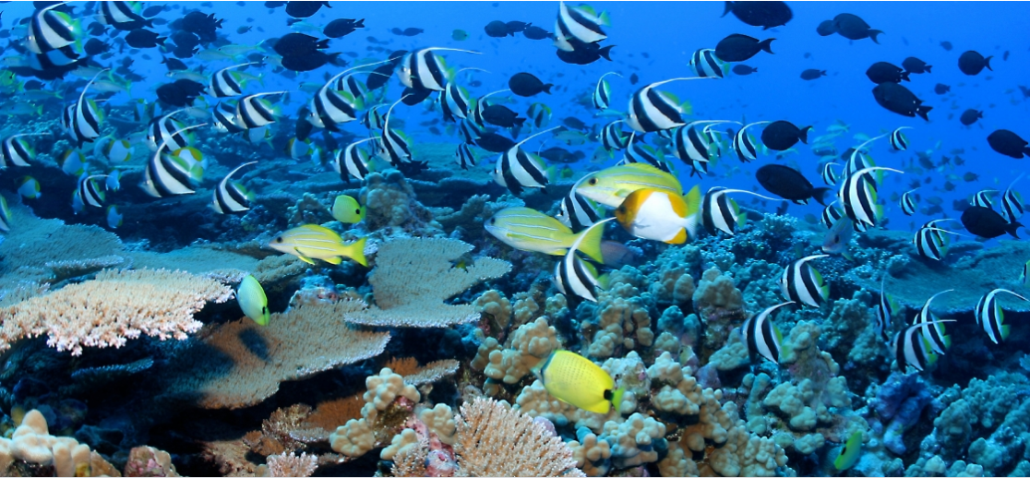

*Figure 1 Coral reef system 3*

*Types of reef systems:*

* **Fringing reefs** grow around islands and continents near coastlines. They have submerged planforms of live corals that extend from the shore seawards just under the surface of the water. Fringing reefs comprise two components a reef flat and a reef slope. Fringing reefs are the most common type of coral reef system.
* **Barrier reefs** occur parallel to coastlines and are separated by deeper, wider lagoons. The reef creates a barrier between the coastline and the open sea. Barrier reefs may sometimes consist of assemblages of smaller reefs separated by a narrow strip of water, e.g., the Great Barrier reef.
* **Atolls** are coral rings primarily located in the mid-ocean that create protected lagoons. Atolls are formed when coral grows on the side of an underwater volcano that terminates above the sea surface. The peak of the volcano erodes gradually and overtime is submerged below the sea surface. The reef may eventually re-emerge as a ring of island or islets. 11

*Benefits:*

* Reduces erosive impacts of wave currents offshore and onshore
* Serve as important nurseries for the spawning and breeding of pelagic fisheries
* Has the highest level of biodiversity of any shallow-water marine ecosystem, e.g., coral reefs support greater than 800 hard species of coral and over 4000 fish species
* Decreases the effect of storm surges and king tides onshore due to wave attenuation
* Possess high recreational and economic value estimated at approximately $9.6 billion of the total benefit of coral reefs.12

*Challenges*

* Climate change, e.g., rising sea surface temperature reduces reef vitality and reef cover
* Loss of coral reef cover increases wave action and erosion onshore
* Erosion due to construction, mining and farming increases sedimentation of rivers and oceans and eventually coral reefs
* Pollution from industrial waste, sewage discharge, oil spills, and agrochemicals lead to eutrophication and algal growth in coral reefs.
* Rising sea surface temperatures and acidification slows reef growth and reduces reef resilience 12, 13

*Chesapeake Bay Oyster Recovery Program (Maryland VA, USA):*

Since the 1800’s oyster population in the Chesapeake Bay have been declining to a point where recent oyster population levels and biomass are less than 1 percent of historic levels.3 The decline has been attributed to overharvesting, diseases, and loss of habitat.4 The project began in 1996 and since then the U.S Army Corps of Engineers has been actively involved in implementing the Oyster Restoration Master Plan.5 The masterplan provides different scenarios in the restoration program which can range from a target of 14,400 – 35,000 acres of restored oyster reefs at an estimated cost between $1.56 – $6.50 billion.6 The masterplan serves as a foundation for working towards the restoration of oyster habitats and populations in 20 tributaries by 2025 which was established by the Chesapeake Bay Protection and Restoration Executive Order.7

*Souris Offshore Reefs (Souris PE, Canada):*

In 2017, two artificial reefs were installed along the Souris causeway to protect it from the impacts of climate change and the effects of storm surges.8 Two reefs were constructed using local sandstone which cost a total of $115,000.9 The reef function in two ways: it reduces the impact of waves and deposits sediment landward of the reefs. The accretion of sediment allows builds up the beach profile and compensates for the loss of sediment caused by erosion. 14 Given its success, the Prince Edward Island government is considering expanding the project in other areas of the island as a response to the frequency of intense storm surges.10

*References:*

1. Stokes, Shawn, et al. *Restoring Gulf Oyster Reefs*. June 2012, pp.5. http://www.mississippiriverdelta.org/files/2012/07/CGGC_Oyster-Reef-Restoration.pdf.
2. Ibid, 5.
3. “Chesapeake Bay Oyster Recovery Program.” *Norfolk District*, 22 Jan. 2019, https://www.nao.usace.army.mil/About/Projects/Oyster-Restoration/.
4. Ibid.
5. Ibid.
6. U.S. Army Corps of Engineers, and Baltimore and Norfolk Districts. *Chesapeake Bay Oyster Recovery: Native Oyster Restoration Master Plan*. Sept. 2012, pp. 6. https://www.nab.usace.army.mil/Portals/63/docs/Environmental/Oysters/CB_OysterMasterPlan_Oct2012_FINAL.pdf.
7. Ibid, 6.
8. “Souris Breakwaters Are Working with the Forces of Nature.” *Wordmark of Government of Prince Edward Island*, https://www.princeedwardisland.ca/en/news/souris-breakwaters-are-working-forces-nature.
9. Ibid.
10. Ibid.
11. National Geographic. (2020). Reef. https://www.nationalgeographic.org/encyclopedia/reef/
12. Scripps institution of oceanography. (nd). VALUE OF CORALS. <https://sioweb.ucsd.edu/projects/coralreefsystems/about-coral-reefs/value-of-corals/>
13. WWF. (2020). What are the main threats to coral reefs? https://wwf.panda.org/our_work/our_focus/oceans_practice/coasts/coral_reefs/
14. Living Shoreline, NC / Oyster Shell Sill

https://www.publicradioeast.org/post/living-shorelines

*Images:*

1. *Oyster Reefs Planted Along Lafayette River*. https://covabizmag.com/wp-content/uploads/2018/01/Low-tide-exposes-an-oyster-reef-on-the-Lafayette-River-Credit-Elizabeth-River-Project-Joe-Rieger-768x576.jpg.
2. *Intertidal Reefs Protect PEI Shoreline from Storm Surge*. <https://www.princeedwardisland.ca/sites/default/files/styles/news_node_featured_image/public/images/news/souris-breakwater-sized.gif?itok=D-Rkar_7>.
3. Figure 1. National Oceanic and Atmospheric Administration. (2019). Coral reef ecosystems. <https://www.noaa.gov/education/resource-collections/marine-life/coral-reef-ecosystems>

**Protect**

**Seawall**

*Overview:*

Seawalls are hard engineered structures built parallel to the shoreline. They have a lower requirement for space than dikes and therefore can be constructed in smaller spaces. 1 Seawalls can be constructed using various materials including reinforced concrete, boulders, steel, or gabions.2 Seawalls serve as the first line of defense during, a storm surges, by protecting coastal infrastructures from wave impact.3

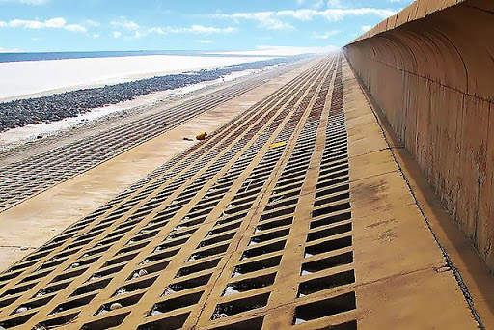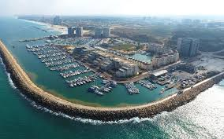

Figure 1 Bohai Bay seawall 3 Figure 2. Seawalls Units Herzliya Marina4

*Types of seawalls:*

* **Steel sheet pile walls** comprise interlocking steel sheets anchored deep beneath the surface of the ground. They are ideally suited for areas with less intense wave and storm surge activity.
* **Gravity walls** depend on the weight of its constituent materials to stabilize the wall in the ground.Therefore, they require stable soil conditions and reinforcement around the base to buffer the effects of **shearing.**
* **Curved walls** are designed with a sweeping curve that helps to dissipate wave impact deflecting it upwards from the base of the wall. Curved walls are designed to reduce the effects of scouring, i.e., removal of sediments from the base of the wall.
* **Brick or block walls** or gabions (wire baskets filled with rocks) comprise of walls constructed from concrete blocks and rocks installed on a man-made slope. The slope shape helps to dissipate the force of the wave 6

*Benefits:*

* Provides protection against coastal flooding and erosion.
* Unlike other sea defense systems, sea walls can be constructed in smaller spaces.
* Possess higher amenity value when compared to other defense structures such as dykes
* Has long shelf life in excess of 100 years compared to soft sea defense approaches, e.g., beach nourishment.

*Challenges*

* Wave impact exerts a significant load on sea walls which tends to increases water dept at the front of the wall
* Reflects wave energy seawards creating turbulence and nearshore erosion
* Causes sediment starvation where erosion in front of the seawall occurs at a faster rate than sediment is deposited through the erosion of the hinterland. This can lower the profile of the beach.
* Prevents the natural inland migration of coastal systems thereby causing coastal squeeze. This leads to a reduction in intertidal habitats such as sandy beaches and saltmarshes 6

*The Seattle Seawall*

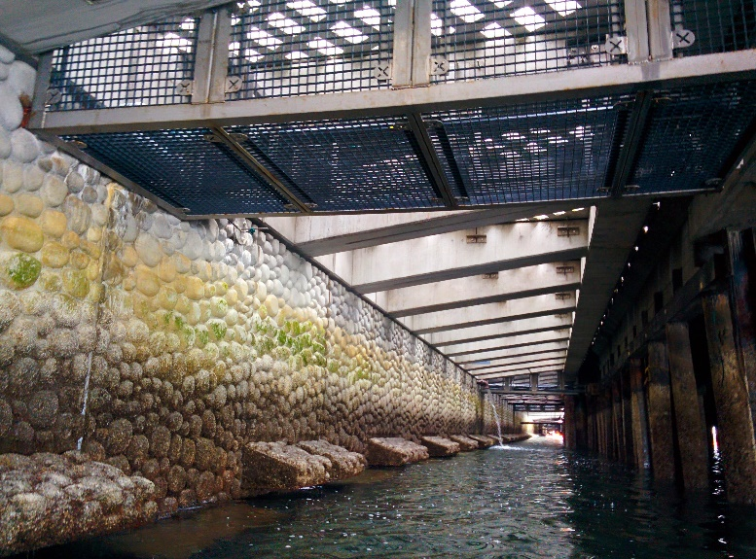

Figure 3. Seattle seawall project 5

The Seattle Seawall was originally built in 1920 and 1936, however, in 2001 and 2004, concerns about the structural integrity of the wall arose. The City of Seattle put forth the Central Seawall Project to replace the 3,700 ft of the seawall with a new seismic-resistant seawall. In addition to the state-of-the-art seawall, the project was also intended to create an unprecedented salmon migration corridor, an enhanced shoreline ecology, and an aesthetically pleasing promenade.3 The seawall features light penetrable surfaces that allow sunlight under the cantilevered where textured concrete panels and habitat benches provide habitat for juvenile salmon.

*Stanley Park Seawall (Vancouver BC, Canada):*

The Stanley Park Seawall is one of the most popular landmarks in Vancouver. It is part of the waterfront path that connects Stanley Park, False Creek, and the Spanish Banks. The construction of the Seawall began in 1917 and was completed in 1980.4 After 1980, the Seawall continued to expand outside of Stanley Park. The Seawall near Second Beach and Sunset Beach was upgraded in 2010 and 2011 to address the erosion concerns that were caused by stroms.5

*References:*

1. Climate Technology Centre and Network. Sea Walls. https://www.ctc-n.org/technologies/sea-walls
2. The Arlington Group Planning Architecture Inc., et al. *Sea Level Rise Adaptation Primer*. pp. 68. https://www2.gov.bc.ca/assets/gov/environment/climate-change/adaptation/resources/slr-primer.pdf
3. “Central Seawall Project: 2017 ASLA Professional Awards.” *Central Seawall Project | 2017 ASLA Professional Awards*, https://www.asla.org/2017awards/320768.html.
4. Vancouver, City of. “The Seawall in Vancouver.” *City of Vancouver*, https://vancouver.ca/parks-recreation-culture/seawall.aspx.
5. Ibid.
6. Salgardo, J. (2017) Types of Seawalls. Sciencing. https://sciencing.com/types-seawalls-8394254.html

*Images:*

1. Magnusson Klemencic Associates. *A Vehicular-Rated Railing Allows Pedestrians to Look over the Bay While Standing on Top of the Cantilevered LPS*. https://www.asla.org/2017awards/images/320768/320768_8.jpghttps://www.asla.org/2017awards/images/320768/320768_8.jpg.
2. *Seawall Along Stanley Park*. <https://quietly-image-uploads.s3.amazonaws.com/item_57095_640px_69b7bbcd8b0143eaa8b3a67ab9d4d856.jpeg>.
3. Figure 1. Melville, D and Chen, Y. (2014). The Great Seawall of China Threatens a Quarter of the World's Shore Birds <http://www.takepart.com/article/2014/11/20/great-seawall-china-threatens-quarter-worlds-water-birds>
4. Figure 2 Israel, M. H. (2014). Seawalls Units Herzliya Marina. <https://econcretetech.com/seawall-units-herzliya-marina/>
5. Figure 3. O’Neill, E. (2018). Seattle's New Seawall Is Built To Help Salmon https://www.opb.org/news/article/seattle-seawall-new-salmon-juvenile/

**Protect**

**Storm Surge Barriers**

*Overview:*

Storm surge barriers are heavily engineered movable or fixed barriers/gates that are closed to prevent flooding during bad weather forecasts.1 They are commonly located across the mouth of a tidal inlet or estuaries to control the water level and prevent excessive amounts of water from entering the estuary.2 Storm surge barriers can be very beneficial for secondary flood protection, on the landward side of the barrier. For example, storm surge barriers can reduce the maintenance and construction cost of secondary storm protection structures.3 Because these barriers require a high level of engineering feasibility studies and because they incur high construction costs, they can be challenging to implement as a cost-effective adaptation strategy. Additionally, storm surge barriers are more appropriate in areas with tidal lets that can be closed.4

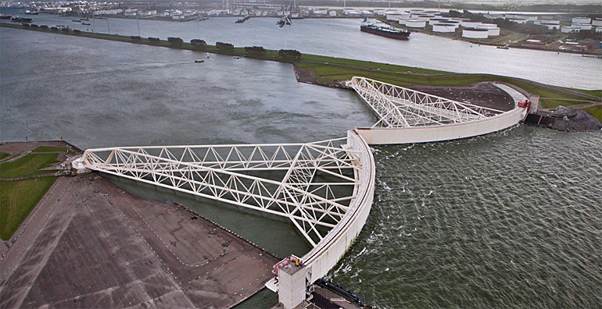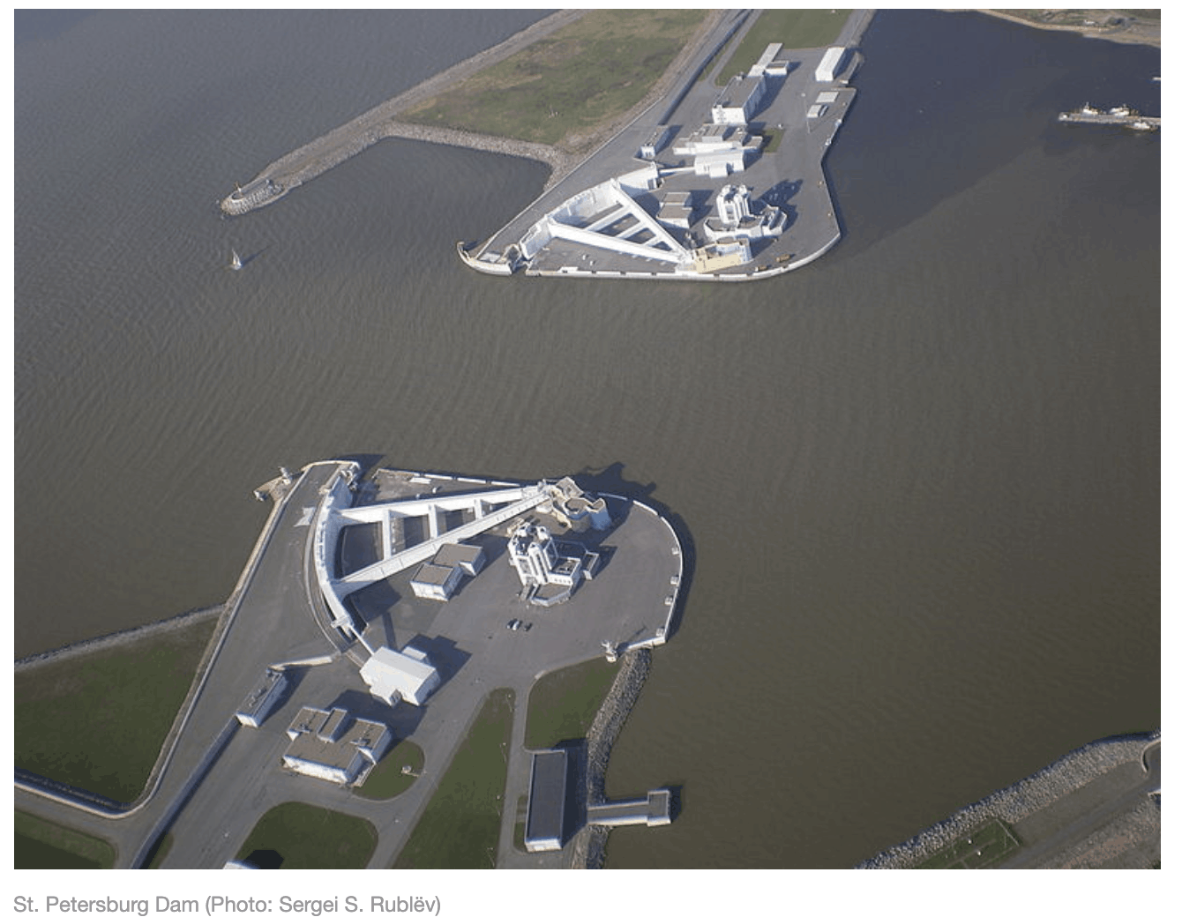

Figure 1. Maeslant barrier, Netherlands2 Figure *2. Hudson River Storm Surge Barriers 3*

*Types of storm surge barriers:*

* **Sector gates** are radial structures comprising two gates with lateral support. Both the gates and arms create a section of a circle that turns around a vertical axis. The gates move based on the water pressure exerted against them.
* **Mitre gates** are flat gates that are comprised of two units. When the two units are closed, they lean against each other forming a wedge in the direction where the water level is highest.
* **Swinging gates or barge gates** are flat and rotate around a vertical axis at one side of a waterway. Swinging gates are designed to prevent tidal intrusions only in low water flow.
* **Rotary segment gates** are cylindrical segments that rotate around a horizontal axis. When a rotary gate is open, the barrier rests on a sill made from concrete that is embedded in the waterway. 12

*Benefits:*

* Protects tidal inlets and estuaries from extreme wave events
* Reduces cost and maintenance of coastal flood defenses on the landward side
* Protects an entire bay area including ports.
* Can be utilized as a bridge or railroad link
* Provides infrastructure support for the development of derelict areas.

*Challenges*

* High construction and maintenance cost
* Affects nearby environments and transfers risk onto nearby properties and communities
* May negatively affect water quality in the bay area
* Mostly suitable for locations where inlets and narrow river mouths can be closed 13, 14

*Thames Barrier (London ENG, UK):*

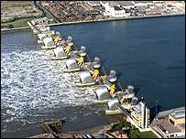

*Figure 3 Thames river barrier UK 4*

The Thames Barrier is one of the largest movable storm surge barriers in the world. It was constructed in response to the frequent tidal surges that London experienced before the Flood Protection Act of 1972.5 Construction began in 1974 and the finished structure was put into operation in 1982.6 According to the Environment Agency, the Thames Barrier cost around £535 million to construct. The Thames Barrier is built to provide a high level of protection for several decades. In 2000-2001 there was an unusual number of closures. Then, it was projected that the trend will continue because of climate change and sea-level rise.7

*La Planche River Aboiteau (Amherst NS, Canada):*

In 2015, the province of Nova Scotia awarded $5 million in the replacement of the old aboiteau on the La Planche River.8 An aboiteau is a one-way storm barrier that controls the flow of water through a dike.9 It is typically used to protect valuable assets such as marshland and agricultural land by reducing the amount of flooding during high tides or storm surges. The design and location of the new aboiteau were intended to reduce the maintenance of existing dikes and to increase the crest elevation to accommodate a rise in sea level.10 The new aboiteau is part of the 241 km of dikes and 260 aboiteau that are operated by the Agriculture Department, under the Marshlands Conservation Act. The act is intended to protect over 43,000 acres of Nova Scotia marshlands.11

*References:*

1. Zhu, Xianli, et al., Technologies *for Climate Change Adaptation - Coastal Erosion and Flooding*. 2010, pp. 54. https://orbit.dtu.dk/files/5699563/Technologies for Climate Change Adaptation-Coastal Erosion and Flooding.pdf.
2. Ibid, 55.
3. Ibid, 57.
4. Ibid, 61.
5. *Flooding in London*. Greater London Authority, Nov. 2002, pp. 21. https://www.london.gov.uk/sites/default/files/gla_migrate_files_destination/archives/assembly-reports-environment-flooding.pdf.
6. Ibid, 21.
7. Ibid, 21.
8. Leys, Vincent, and Daniel Bryce. *Adapting to Climate Change in Coastal Communities of the Atlantic Provinces, Canada: Land Use Planning and Engineering and Natural Approaches*. Mar. 2016, pp. 63. https://research.fit.edu/media/site-specific/researchfitedu/coast-climate-adaptation-library/canada-amp-arctic/canada---atlantic/Leys--Bryce.--2016.--CC-in-Coastal-Communities-of-the-Atlantic-Provinces,-Land-Use,-Engineering-Natural-Approaches.pdf.
9. Ibid, 63.
10. Ibid, 63.
11. Cole, Darrell. “Colwell Announces $5-Million Aboiteau for LaPlanche River: Cumberland News Now.” *News*, 23 Sept. 2014, <https://www.cumberlandnewsnow.com/news/local/colwell-announces-5-million-aboiteau-for-laplanche-river-30277/>.
12. Deltares. Enabling Delta Life. Overview storm surge barriers. http://www.masterpiece.dk/UploadetFiles/10852/25/Deltares_2018_Overview_storm_surge_barriers_komprimeret.pdf
13. Esteban et al. (2019). Handbook of Coastal Disaster Mitigation for Engineers and Planners 2015, Pages 723-747. Chapter 33 - Adaptation to Sea Level Rise in Tokyo Bay: Opportunities for a Storm Surge Barrier? https://www.sciencedirect.com/topics/engineering/storm-surge-barrier
14. Climate Technology Center and Network. (nd). Storm surge barriers and closure damshttps://www.ctc-n.org/technologies/storm-surge-barriers-and-closure-dams

*Images:*

1. Roberts, Andy. *Thames Barrier*. <https://upload.wikimedia.org/wikipedia/commons/thumb/4/49/Thames_Barrier_03.jpg/1280px-Thames_Barrier_03.jpg>.
2. Figure 1. Netherlands News. (2018). Storm Eleanor: Dutch national water authority closed all five big storm surge barriers. <https://www.dutchwatersector.com/news/storm-eleanor-dutch-national-water-authority-closed-all-five-big-storm-surge-barriers>
3. Figure 2. Science Hudson.org. (2020). Hudson River Storm Surge Barriers <https://www.scenichudson.org/our-work/advocacy/storm-surge-barriers/>
4. Figure 3. BBC New. 2007. New Thames barrier could be built http://news.bbc.co.uk/2/hi/uk_news/6964281.stm